Amazon VPC
A virtual private cloud (VPC) is an isolated network that you create in the AWS Cloud.
It creates a boundary where your applications and resources are isolated from any outside movement.
3 main factors:
- The name of VPC
- The region, you choose
- The IP range
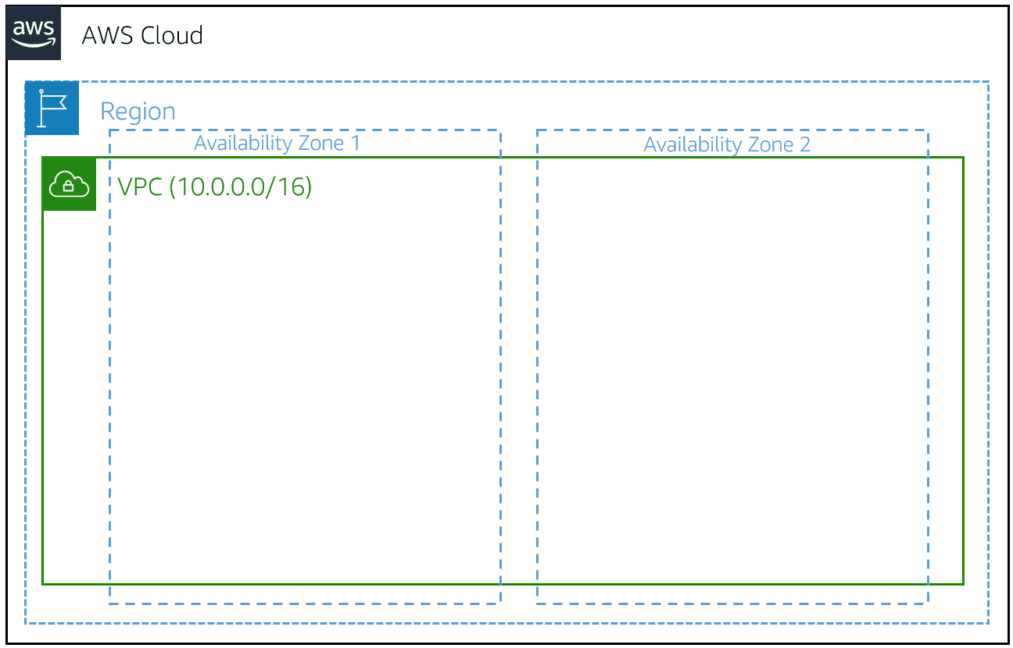
Creating a subnet
After you create your VPC, you must create subnets inside the network.
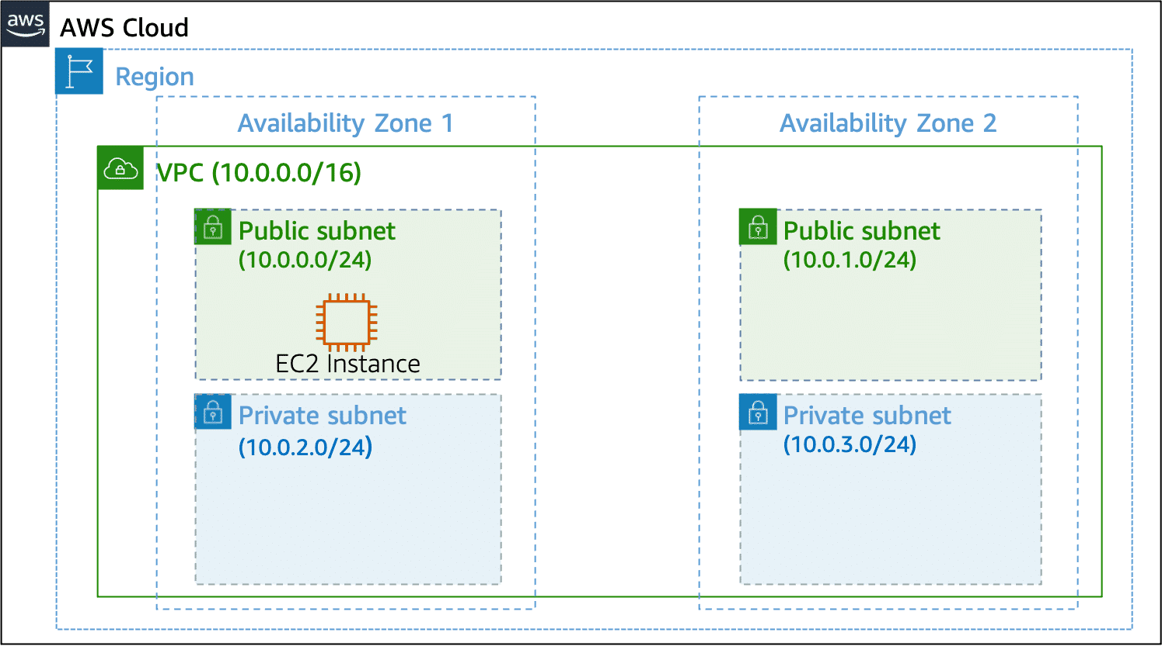
When you create a subnet, you must specify the following:
- VPC that you want your subnet to live in—in this case: VPC (10.0.0.0/16)
- Availability Zone that you want your subnet to live in—in this case: Availability Zone 1
- IPv4 CIDR block for your subnet, which must be a subset of the VPC CIDR block—in this case: 10.0.0.0/24
Internet gateway
To activate internet connectivity for your VPC, you must create an internet gateway. After you create an internet gateway, you attach it to your VPC.
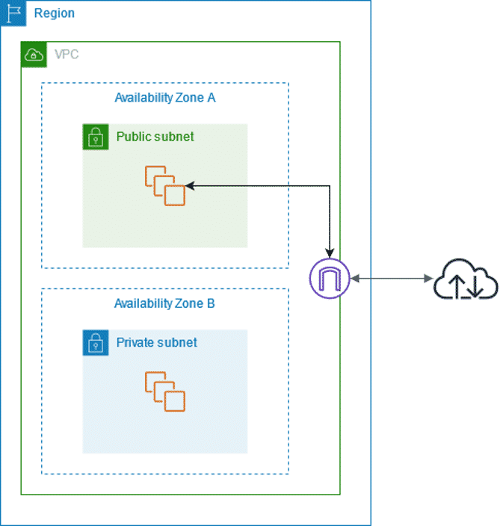
Virtual Private Gateways:
A virtual private gateway connects your VPC to another private network. When you create and attach a virtual private gateway to a VPC, the gateway acts as anchor on the AWS side of the connection.

Resources
For more information, see the following resources:
(opens in a new tab)(opens in a new tab)
- AWS user guide: What Is Amazon VPC?(opens in a new tab)
- AWS user guide: How Amazon VPC Works(opens in a new tab)
- AWS user guide: How AWS Site-to-Site VPN Works(opens in a new tab)(opens in a new tab)
- AWS user guide: What Is AWS Direct Connect(opens in a new tab)?

